**Calendar Spreads**

DEFINITION: Selling one option and buying another option of the same strike price but different Expiration month.

This strategy is one of the basic spread positions that is used by traders of all experience levels. Calendars are designed to collect the THETA (time) decay of the short option in the spread while maximizing the time value of the longer term option.

The type of Calendar spread that I am going to focus on for this presentation, the Put Calendar, is just one of the different types of calendars that are possible. I have had very good returns on this type of calendar. The position consists of Selling one “Front Month” Put and Buying one “Back Month” Put. This will be a debit trade.

**Criteria for Entering the Spreads**

Select a stock or underlying that you do not expect to make big moves before the expiration of the front month option, such as earnings, acquisitions, SEC inquiries, drug tests, etc. Stocks or underlyings that trade sideways or with a slight trend are preferable.

Select a stock with good liquidity. **Open Interest should be at least 15 times that of your sell or buy volume. An exception is when the month is newly listed and the liquidity has not yet built up. Look at previous months to see if they have good liquidity.**

Try to use stocks above the $60 price range to avoid having too many contracts which cause higher commissions and slippage.

Market Capital should be over $ 2,500 M

Minimum Volatility should be 30%

You want the front month option to have a larger Implied Volatility than the back month option. **BUT if the difference is too large, (more than 5%), you must be very careful because this could be due to an upcoming event that you may not know about and it can cause large moves which you don’t want. Frequently insider information is the cause for high IV differences when there is no expected event apparent.**

A good time to enter these spreads is right after earnings announcements and after the stock has made its move **(usually the next day or two).**

**Entering the Trade**

You will Sell “Front Month” Put and Buy “Back Month” Put. This is a debit trade. The front month Put should be 3 to 8 weeks from expiration. The back month Put should be one month later. **For example: if you sell the January Put, you will buy the February Put. Sometimes you can’t enter two consecutive months. When that happens you can still enter a trade but it is not the ideal situation for this particular strategy. Try to avoid it.**

You want to stay as close to ATM as possible. If the stock is very volatile, enter three strikes – one ATM, one above and one below. **This will lower your initial ROR but will enhance the probability of success and reduce the number of adjustments until expiry.**

Legging in:If you are uncertain about the market or its direction and you have plenty of time, you can ‘leg in’ and start with just the ATM spread. In the next few days or weeks, you can add the other spreads at the price of the stock depending on which direction it moves.

If the price of the stock is in between strikes, enter the one above and the one below.

**Finding and Analyzing Stocks**

Start a watch list for potential Calendar spreads. Search for candidates in the TOS Scan tab. Set your scan criteria as shown in the picture below. You will get a list of several stocks to investigate.

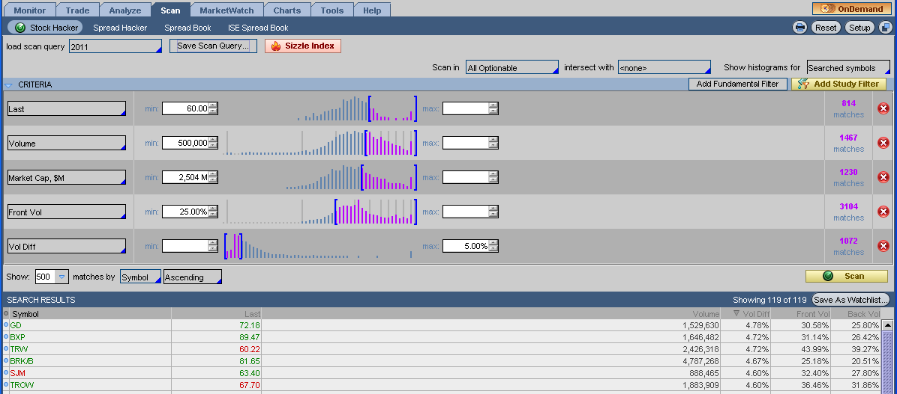

Customize the search results to show “Symbol, Last, Volume, Vol Diff, Front Vol, and Back Vol”

Click on Vol Diff to get the scan results sorted from biggest to smallest. Make sure the Front Vol is larger than Back Vol.

Now make sure there are no earnings in the front month. Also make sure options are available for two months in a row. If all looks good to this point the next step is to analyze them.

**ANALYZING THE TRADE**

Go to the Analyze Tab. Enter the symbol you want to analyze. Click on Add Simulated Trades. On the options chain find the front month ATM Put. Right click on the bid. Go to ‘BUY’, Calendar. The spread will come up under Positions and Simulated Trades.



Change the Date (on the far right) to the expiration date of the front month option.

Directly under “Reset Slices” you will see MARGIN REQ (if you have a margin account) or BP EFFECT. To the left of that you will see P/L OPEN. Divide the P/L DAY by the MARGIN REQ to get your ROR. You want a minimum of 100% (January 2011: In this environment it is not easy to find 100% ROR. You may settle for 80%) The more days until expiry from your front month option, the higher percentage ROR you want. ~~In the sample above, the stock price is very close to a strike price. In this case I would just enter the one strike and adjust as the stock moves.~~

**Entering more than one strike:**

When the price is between strikes simulate the one above and the one below and then do your division. If your ROR looks good then continue analyzing by going to the RISK PROFILE tab. You will see a bell curve of your spreads. Add contracts to one or the other of the strikes to get the stock price line at the peak of the curve. Once you enter the trade, the curve will be what you will use to monitor and adjust the trade.



**MONITORING AND ADJUSTING**

Adjust a position when the stock price has reached the lowest or the highest strike of your spread. Look at the Technicals and support and resistance before adjusting to avoid any unnecessary adjustments. The tendency for new traders to this method is to over adjust. Watch Your Technicals!

When the price has moved up above the highest strike, sell the lowest spread and buy a new one just above where the price of the stock is. Do the opposite if the price moves down. Look at your curve and simulate the adjustment first, getting the price line as close to the top of the curve as possible. This will maximize your Theta which is what we want to do throughout the entire trade.

Your adjustments will usually not be done for a loss. If they are at a loss, it will be minimal. Unless the stock moves dramatically, very quickly, your adjustments should be for a small profit.

If the stock gaps up or down look at your expiry P/L and see if it is within the break even points. If you don’t think the stock will stage a pullback or rally, sell the spread. Do not panic, you have a hedged position with a limited loss.

**EXITING THE TRADE**

Exit all spreads one week before expiration. Of course the closer you get to expiration the more Theta you will make. **More experienced traders may want to collect that extra Theta and exit on Monday or Tuesday of expiration week. It all depends on your Risk Factor.**

You can also exit at a predetermined percentage of profit.

Early assignment is possible when a part of your spread is in the money. You will be assigned the stock and be left with the long Puts. Sell the long Puts along with the stock. If you cannot balance the rest of the spread, exit the entire position. If you can balance it and there is enough time to expiration, you can keep it longer.

**Best Type of Market**

This spread works best in stable markets and low volatility. **This does not mean that it doesn’t work in other markets.**

In volatile markets premiums are higher but you have to adjust more often. Because of this you need higher ROR spreads to compensate for the volatility.

This is not a good time to enter this method of Calendar Spreads. The reason is that back month volatility is higher right now than front month.

In a stable and low volatility year, one can expect returns of more than 200%

In a reasonably stable year returns of 150% to 200%.

In a very volatile year, returns of 100% or less are possible.

**Calendar**

Entry:

* Sell a Front Option ATM and Buy a Back option ATM. (Debit)
* Enter 3 strikes, 1 ATM, 1 OTM and 1 ITM keeping them close together.
* If underlying is between two strikes, enter the one above and the one below.
* Keep them close in time, no more than 2 months apart.
* Do not enter in an aggressive trend or around earnings.
* Allow 20-56 days before expiration.
* Look for Front month IV to be higher than Back month IV (but not more than 5%)
* Good time to enter is after earnings.
* Find stock with good liquidity. Open Interest at least 15X buy or sell volume.
* Find stocks with price of underlying above $60.
* Analyze the trade to be sure you are getting minimum of 80% return at date of expiry.
* Have minimum of 45% probability of the underlying staying within breakeven points.

Adjustment:

* Adjust when the underlying has reached the lowest or the highest strike of the underlying.
* When it has moved up above the highest strike, sell the lowest spread and enter a new one just above where the underlying is. Vice versa if it goes the other way. This keeps you neutral and gives maximum Theta.
* If it gaps up or down look at expiry P/L and see if it is within BE. If so, sell the spread if you don’t think it will pull back or rally.
* Analyze technicals before adjusting.

Exit

* Exit one week before expiry or when you have made 40-60% of profit potential.
* Roll front month options (if you have 2 months separation) a week to 10 days before expiry.
* If you get assigned sell the long position along with the assignment.

DEFINITION

 Selling one option and buying another option of the

same strike price but different expiration month =>

Debit Calendar spreads.

FOCUS

 We will focus on the “Market Neutral Strategy” to

build a portfolio of several spreads from different

stocks, ETF’s, etc.

 I don’t like to do calendar spreads on Indices due to

execution disadvantages.

WHAT MAKES A GOOD CANDIDATE?

 Check list:

 Stock price above $60 preferable. Lower price stocks

tends to need more adjustments. You might consider

lower price stocks is profit window in the p/l curve is

wider => greater than 7%.

 Check that the stock had already reported its earnings

and it is good stock. Actually, most of the times the

best entry point it is after the stock has reported

earnings and the stock has already made part of its

move. WHAT MAKES A GOOD CANDIDATE?

 Check list:

 Stocks or underlying that trades sideways will need less

adjustments than trending stocks, but you can still

select trending stocks with not big moves.

 Liquidity. The volume of the stocks should be above

500,000 .

 Market Capital, over $ 2,500 M

WHAT MAKES A GOOD CANDIDATE?

 Check list:

 Minimum Volatility:

Front Volatility =30%,

 Front volatility and Back volatility. Select the underlying

that has front volatility higher than the back volatility.

MinVol. Diff= 0.5% MaxVol. Diff= 3%.

This difference should be no more than 5%. Higher

difference might be due to an upcoming event that can

cause a large move on the underlying.

ENTRY RULES

 When to enter? 3 to 8 weeks to expiration, with one or two

months separation between short and long options. If

market is too volatile select only one month separation.

 Enter one, two or three spreads, to enhance probability of

success, and made pl curve wider on the top of the bell

curve. The wider the bell curve peak is the less adjustment

is needed.

 Use two strike prices if the underlying price is between two

strikes, one above and below, and complete the position

with the third spread with the underlying move.

BUILDING THE POSITION

 Try to be ATM as much as possible with the

combination of your spreads in the range that you

expect the stock to be during the period of time of

your trade

 Simulate in the analyze tab in TOS, the position you

are evaluating at expiration. Look that the probability

of the position is 50% or above at the breakeven points

of the underlying. This is usually more difficult with

one ATM spread.

 Check the rate of return (ROR). Revise how much is

the pl open profit on expiration and divide it from the

risk shown. If rate of return is above 85% for 3 or 4

weeks to expiration, you can still take the trade.

Normally if you enter with more weeks to expiration

the ROR shown tends to be higher than 140% to even

200% or more, like on ETF’s.

 Check the window range of profit.

 Stock price vs. each break even point should be higher

than 7 %

 The probability can be increased by adding more

spreads to the position, the adjustments needed will

be decreased as profit window gets wider, but at

expense of less potential profit.

 Make the calendar spreads only with puts as they are

cheaper most of the times and will increase its ROR.

Only use calls when they are cheaper or the same price

than the puts or for liquidity considerations.

MONITORING AND ADJUSTING

 When the underlying has reached the lower or higher

strike, look for support and resistance before

adjusting.

 When the underlying has moved above the higher

strike, sell the lower one and add a new one above

where the underlying is. The same applies on the down

side. The idea is to neutralize the position and get the

maximum Theta.

 When the underlying gaps up or down.

 Monitor the Delta, Gamma and Theta of your portfolio

PORTFOLIO AND HEDGING

 Enter 10 or 15 stocks and allocate the capital evenly and

from different sectors of industry. You can place more

money in the stocks you are more familiar.

 Use 50% of your capital and leave the rest for adjustments.

Use more or less depending on your level of experience

trading.

 Have two expiration cycles in your portfolio at the same

time.

 Hedge your portfolio for sharp market declines. You can use

ATM SPY puts and rolling them as needed. Use beta

weighted using SPY to get the delta required for hedge

EXIT RULES

 Exit all positions one week before expiration.

 Exit positions when you have made 40%-60% of profit

Potential

RATE OF RETURN EXPECTED

 Calendar spreads work best on stable market

environments with low volatility.

 It can work on high volatility environments but with

frequent adjustments.

 In a stable market with low volatility year the ROR

could be more than 200%. ( VIX below 20%)

 Moderate volatility market year, the ROR can be

between 150%-200%. (VIX between 20%-35%)

 Volatile market year the ROR is possible 100% or less.

(VIX above 30%)